User manual Voice trainer

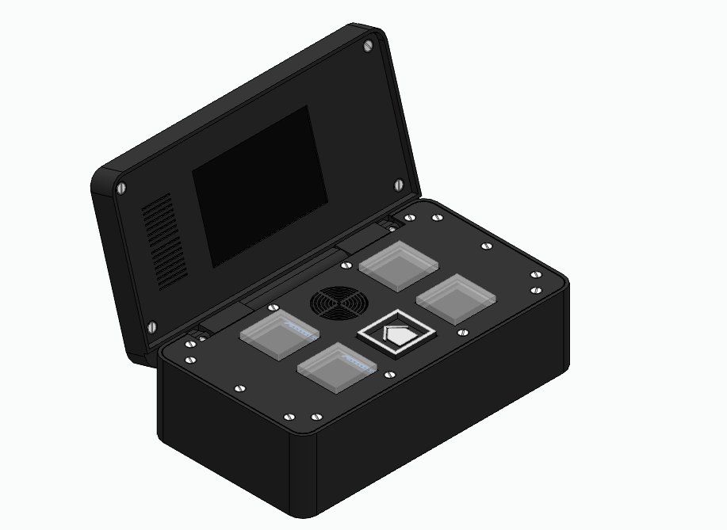

How to use

Backside
To turn it on, there is a power button on the back. The system can be charged even when it is off, through USB C on the back. This USB C is not for uploading.

Time
When on, it shall try to gain the time through wifi. To let it connect to wifi, the user needs to turn on a hotspot in their phone with the following settings:
- Network name: Voicetrainer
- Password: APPSS62025
The wifi name and password are set in code and can only be changed by a programmer.

User interface
There are five buttons for interface. Four have a display, one has the home button. When the home button is pressed the UI goes to home from wherever it is. When a button without function is pressed, it also goes home.
On home the other four buttons are for navigation:
- The clock with bed icon: Here you can check and set alarm for waking up.
  - Edit: lets you edit the alarm
    - With the + or – the time that is underlined can be changed with 5 minutes
    - lets you change the next setting
    - Lets you go back without saving changes
  - On/ off lets you turn the alarm on or off
- The clock with pill jar icon: Here you can check and set 8 different alarms for taking pills.
  - Choose or to cycle through numbers
  - Choose a number to edit alarms
    - With the + or – the time that is underlined can be changed with 5 minutes
    - lets you change the next setting
    - Lets you go back without saving changes
  - On/ off lets you turn the alarm on or off
- The head with soundwaves: Here you can speak to the device which gives you visual feedback.
  - The orb needs to be centred
  - Elephant is too heavy voice
  - Bird is too high voice
  - + or – is too loud or too quiet
  - EDIT is for calibration: Not implemented

Shortcomings
Sometimes when turning on the power switch, it will not boot correctly. Switch it on and off again.
Sometimes when an alarm goes on, it will reset.
Charging and current capacity is not displayed. Battery icon is always full.

Modifying
Everything is reachable, if you remove enough bolts.

Source
All software, Hardware, models and different files used can be found on the following github: teunrensing/APPS_S6_25: Dit is een repo voor het APPS project
Code can be cloned or downloaded from here. Example download .ZIP: 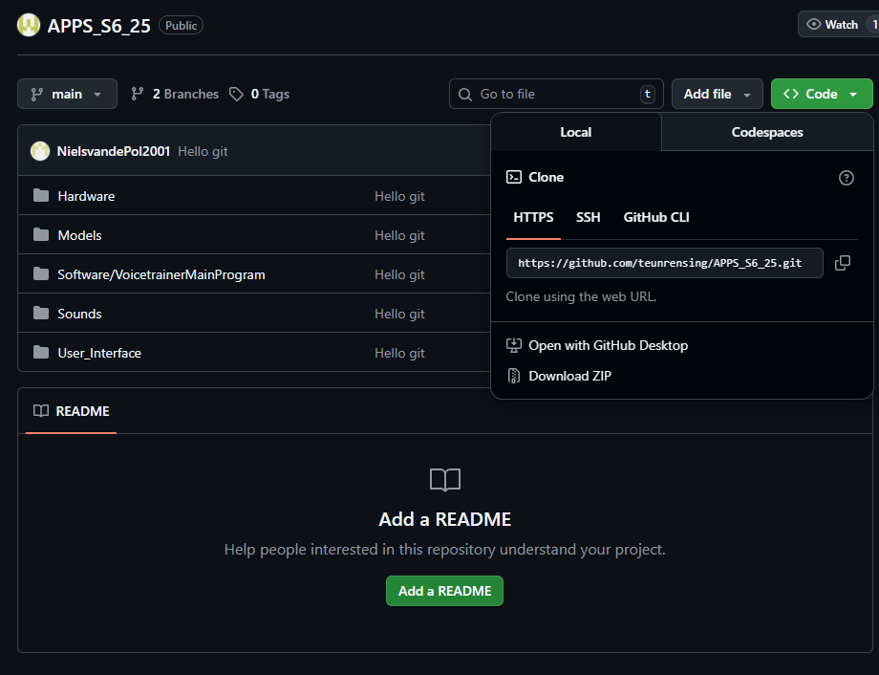
A more chaotic, more details and less relevant information about this project, can be found in teams: (1) Teams en kanalen | S6 APPS | Microsoft Teams

Software
The VoicetrainerMainProgram or VoicetrainerButtonProgram folder can be opened with Visual Studio Code with the Platformio extension. From there it should be able to build.
- The VoicetrainerMainProgram can be uploaded through USBC at location 1.
- The VoicetrainerButtonProgram can be uploaded through USBC at location 2.
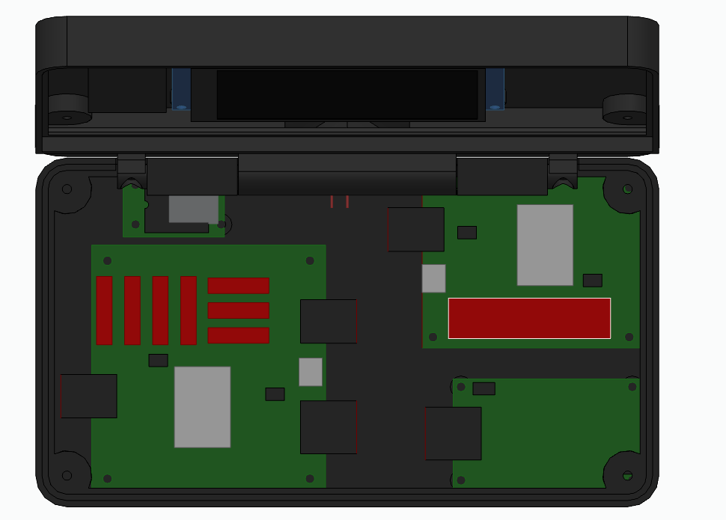
MP3
2
1

Sounds
New sounds can be placed on the sd card of the mp3 module. For more information about it see the datasheet: DFR0299-DFPlayer-Mini-Manual.pdf

UI main display
The UI is made in EEZ studio. The User_Interface.eez-project can be openend in EEZ studio. When modified, the build files should be replaced here: Spraaktrainer\Software\VoicetrainerMainProgram\lib\eez_ui

Models
All files are designed in Solid Edge (free community edition), but STL files are also added.

Hardware
All tree PCB’s are made in Kicad and can also be modified there.

